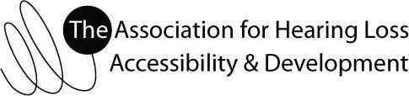

AHLAD Non-profit Donation Form

The Association for Hearing Loss Accessibility & Development is an active South African based association formed with the following Mission:

To serve as a Forum for the advancement of all persons with hearing loss so as to enable them to attain their maximum level of independence and integration into the community as well as the prevention of the occurrence of deafness and hearing impairment, in line with the UN Convention on the Rights of Persons with Disabilities.

Donor Information

Date:___________________

Name:___________________________________________________

Address: ____________________________________________________________________________________
F ____________________________________________________________________________________

City:__________________________ Province:__________________________ Postal Code:________________

Phone:__________________________ E-mail:__________________________________________________

Please describe donation if non-monetary:_________________________________________________________
F___________________________________________________________________________________________F___________________________________________________________________________________________

If you would like to make a financial donation, please complete the following section:
R25 | R50 | R75 | R100 | Other: R______

I would like to donate the following amount:

We gladly accept these forms of payment (check one): Cheque Debit Order EFT Cash

Comments:__________________________________________________________________________________

Banking Details
Account Name: Association for Hearing Loss Accessibility and Development
Type of Account: Cheque
Bank:
Branch:
Branch Code:
Acc. No:

Association for Hearing Loss Accessibility & Development (AHLAD)
Phone: Michele Tonks at 082 781 7715 or SMS Fanie on 082 820 7358
Website: www.ahlad.org

